Alex Bradbury

Minwoo Cho

CENG 340

Professor Deborah Sills

Lab 3: Part I: Oxygen Depletion Kinetics

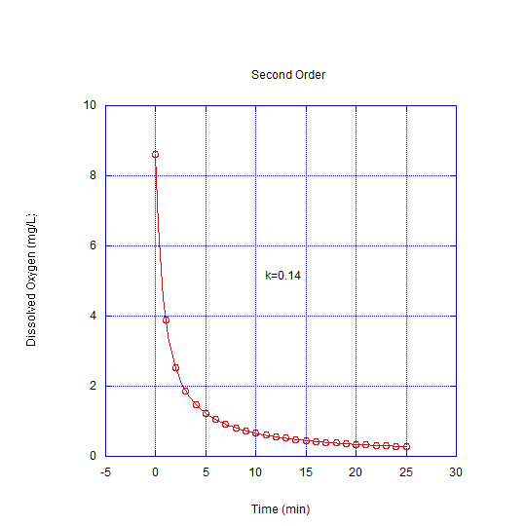

Figure 1: Plot of Data Set 1; K= Reaction rate

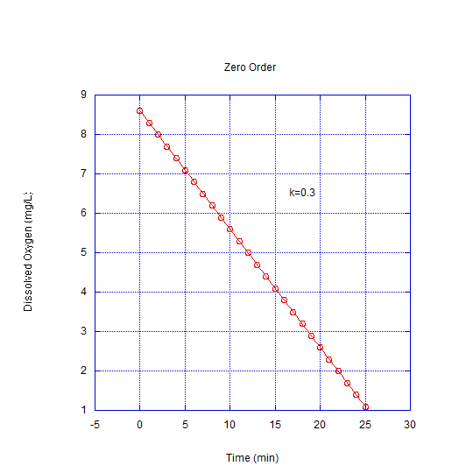

Figure 2: Plot of Data Set 2; K= Reaction rate

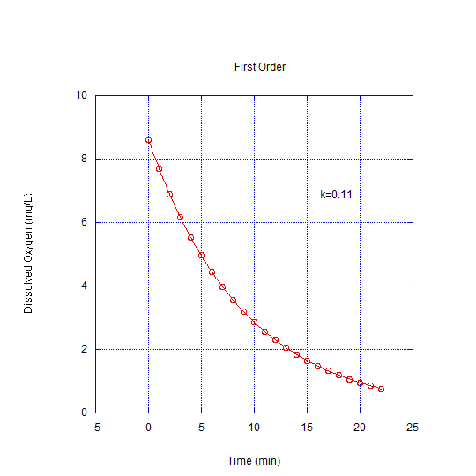

Figure 3: Plot of Data Set 3; K= Reaction rate